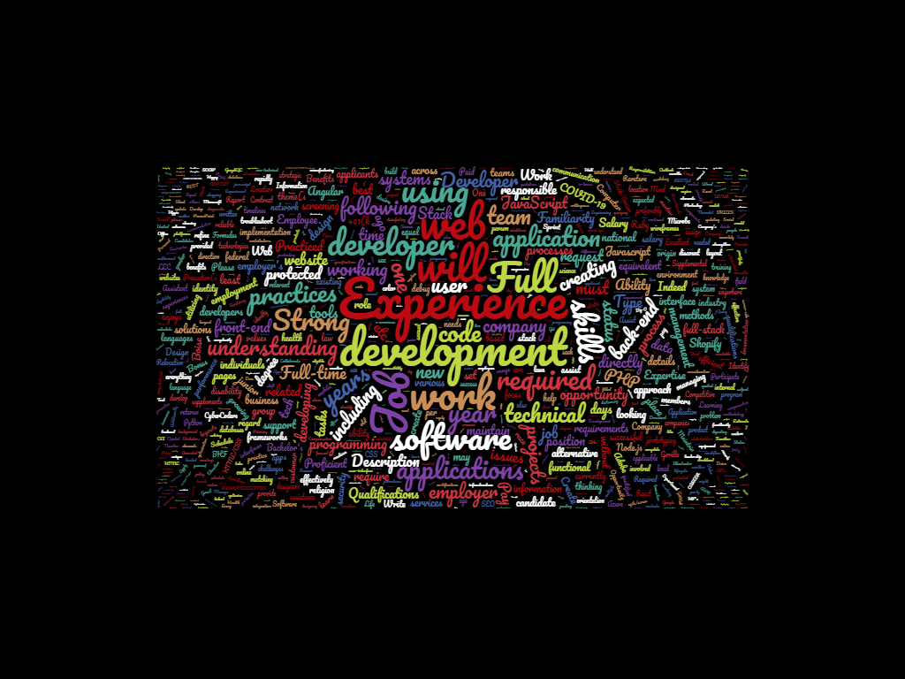

**Most Common Words (that matter)**

1. Experience
2. Development
3. Application/Software
4. Skills/Understanding
5. Back-end/Front-end

**Top Ten Target Companies**

1. Northrop Grumman
2. Nucor
3. Amazon
4. Drake Cooper
5. Scentsy
6. RUHM
7. T4s Partners
8. Accenture
9. Happy Hippo LLC
10. Blizzard